### CHAPTER 1 : VARIABLE & DATA TYPE
General Notes
# In Terminal
1. Create virtual environment (venv), is to to isolate project dependencies and prevent conflicts with other projects or your system's global Python installation.

2. Create (venv) >>
python -m venv myvenv

3. Activate (venv)>>
myvenv\Scripts\activate

4. Command Python in new terminal >>
cd py

5. Run python file in terminal >> py yourfilename.py
contoh : py chapter1.py

6. Please save dulu at the coding tab, if not save, cannot run at terminal.
Click ctrl+s at the tab to save

# VARIABLE
def: name assigend to particular data
cth:
a = 1
b = 3
job = waiter

# DATA TYPE
1. String >> " "/' '/""" """
2. Integer number >> 2
3. Float >> 3.5
4. Boolean >> True / False

Contoh:
name = "Fatin" # String
age = 33 # Integer
weight = 78.56 # Float
is_female = False # Boolean

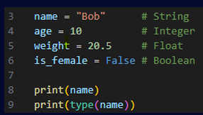

# PRINT
1. Print the message or results in screen
print ()

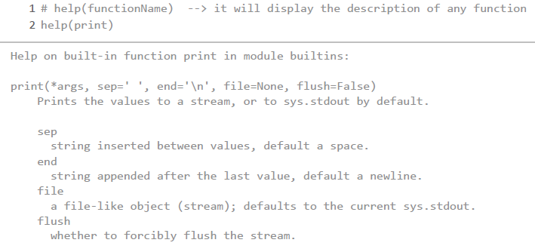

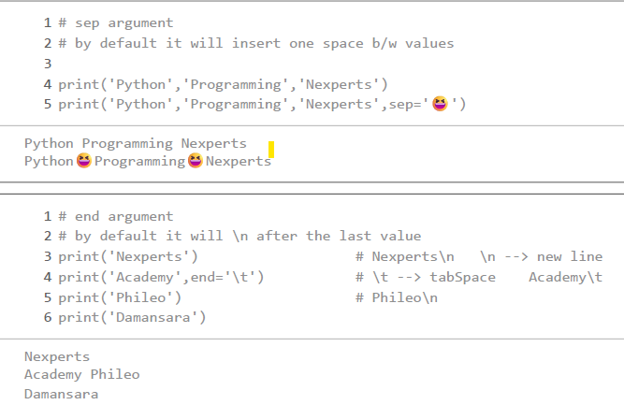
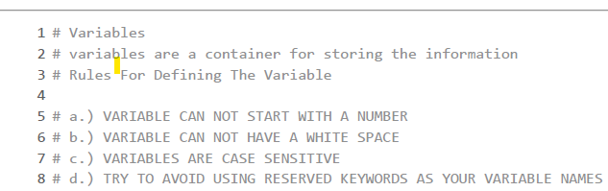

2. Determine Type of Data
print (type(variable))
contoh :
b = 16
print (type(b))

Jawapan: Int

# MATH OPERATIONS
x = 10
y = 2

print(x + y) # Addition
print(x - y) # Subtraction
print(x * y) # Multiplication
print(x / y) # Division
print(x // y) # Floor Division
print(x % y) # Modulus
print(x ** y) # Exponentiation

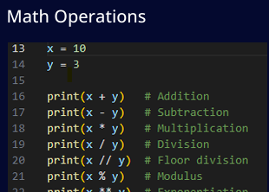

# Exercise - Convert Celsius to Fahrenheit
C = 25
F = (C *9/5 + 32)
print(F)

### CHAPTER 2 : STRING MANIPULATION
# STRING MANIPULATION
# A. STRING CREATION
1. Single Quote (one liner)
2. Double Quote (one Liner)
3. Triple Quote (Multiliner)

single_quote = 'Hello'
double_quote = "World"
triple_quote = """ I am still new
and hope I can learn Python and understand it well"""

***** ZAROL SAID, PLEASE USE DOUBLE QUOTE INSTEAD OF SINGLE QUOTE

# B. STRING INDEXING & SLICING

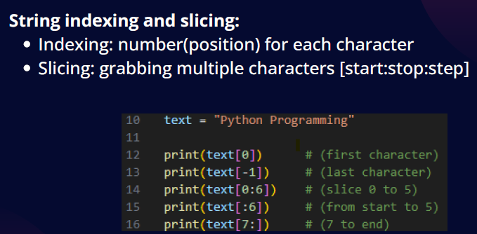

print (text[7:16:2]) # (from 7 to 15, every 2 step)

Jawapan:
P
G
PYTHON
PYTHON
PROGRAMMING
PORMI
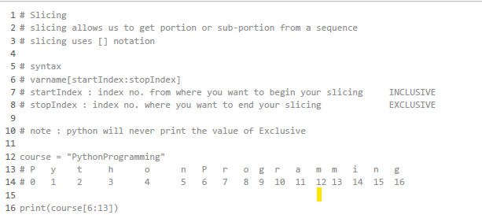
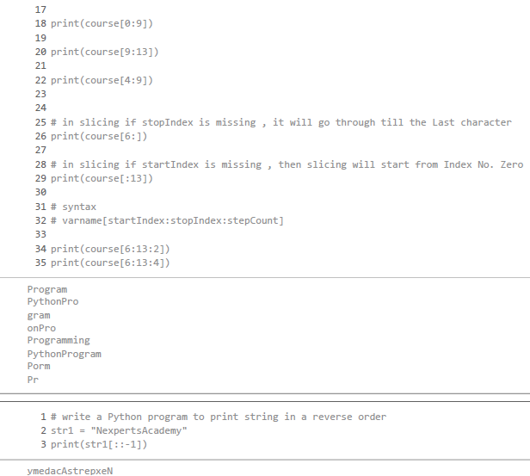

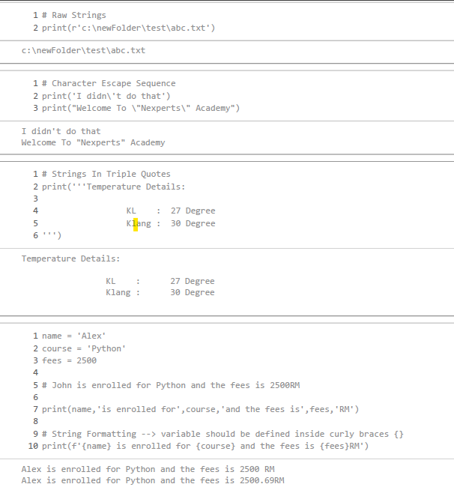

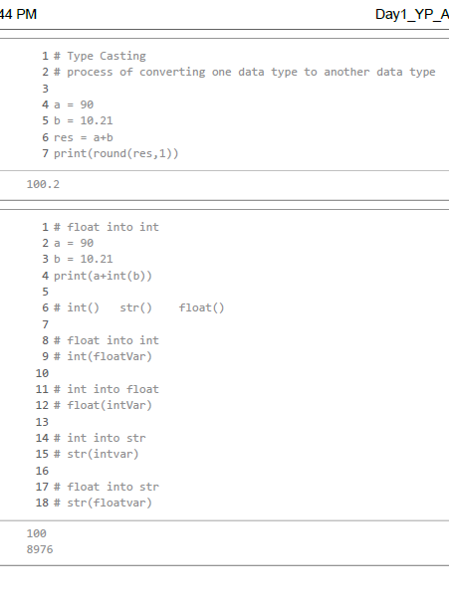
# C. STRING METHODS
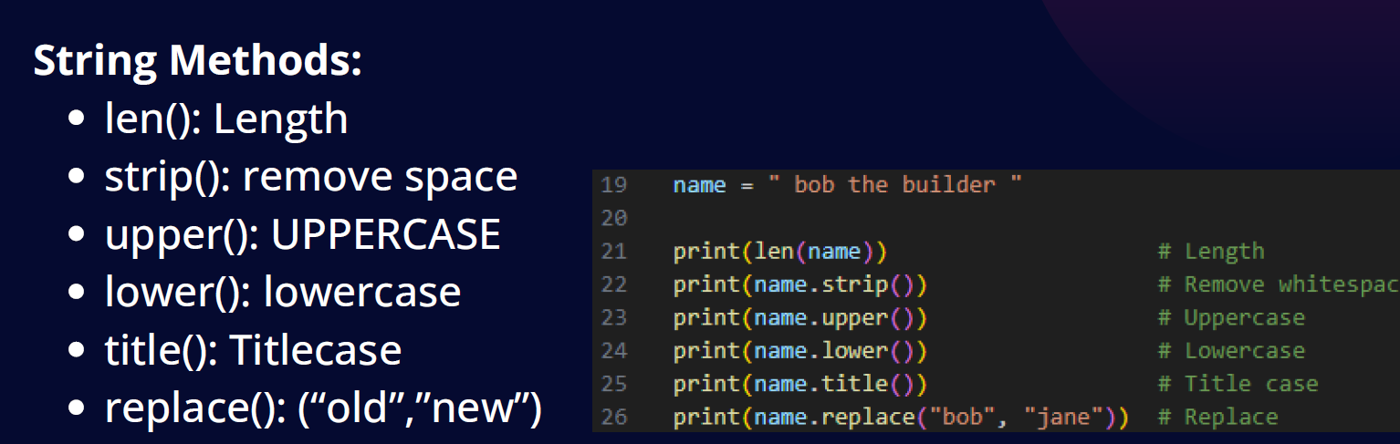

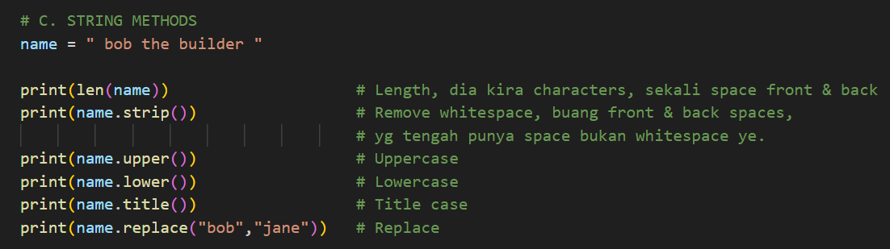
jawapan:
17
bob the builder
BOB THE BUILDER
bob the builder
Bob The Builder
jane the builder
# D. STRING FORMATTING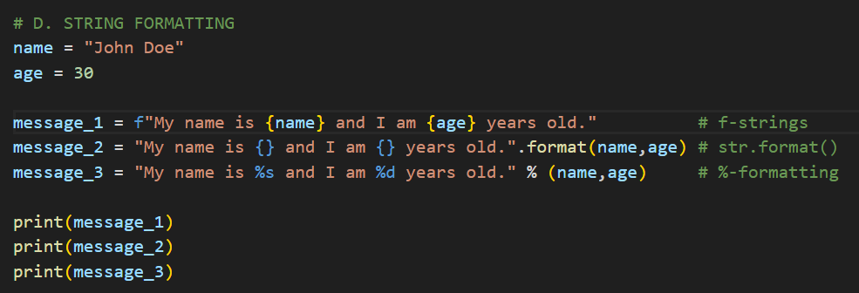

jawapan:
My name is John Doe and I am 30 years old.
My name is John Doe and I am 30 years old.
My name is John Doe and I am 30 years old.

